**MISO vs SISO**

**INTRODUCTION:**

The aim of this project is to simulate a MISO and a SISO system using the orthogonal space-time code G(x1,x2), i.e., Alamouti Scheme, in which x1 and x2 are chosen from QPSK signals and to compare them in terms of Bit-Error-Rate(BER) as a function of Signal-to-Noise Ratio(SNR).

**IMPLEMENTATION:**

1. A MISO system with *Mt* = 2 transmit antennas is designed with the orthogonal space-time code G(x1,x2), i.e., Alamouti Scheme, in which x1 and x2 are chosen from QPSK signals.

2. A conventional SISO system sending out a single QPSK symbol at each time slot is also implemented.

3. The channels are assumed to have Rayleigh fading and are modelled as independent complex Gaussian random variables with mean zero and variance one, i.e., CN(0, 1).

4. The additive noise at the receiver side is also modeled as independent complex

Gaussian random variables with mean zero and variance one.

**OBSERVATION:**

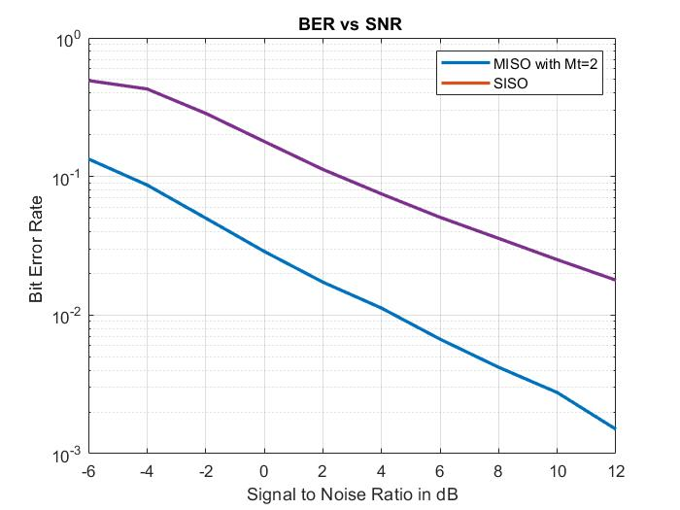

It is clear from the graph that the MIMO system with Mt= 2 and Mr = 1 has better BER than the SISO system. As the SNR value keeps on increasing the BER continuously decreases giving better performance for both systems. The gap between the performance of the two systems is small for lower SNR but as the SNR increases we can see the gap continuously in performance of the two systems keep on widening correspondingly.